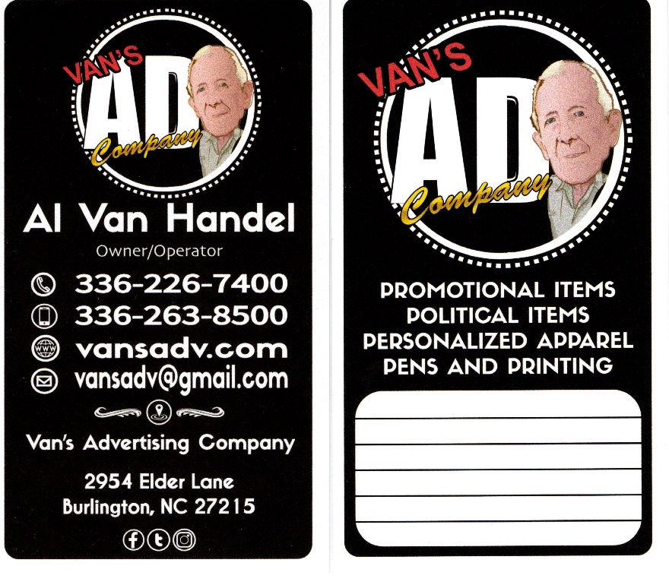

**Prices Subject to Change without notice. Shipping prices may be incurred. Taxes not included. Design / Artwork extra. Call for quote. *Select group of shirts. REV5/5/2021**

**2021 PRICE SHEET**

**Trifold Brochures**

**ASK ABOUT OUR YARD SIGNS WITH GOOD UNION LABEL**

**12” x 24” Full Color** Set of 2 - **$75**

**8.5” x 11” - 100# Gloss, Full Color, 2 Sides** **Qty** 2,500 - **$243.00** 5,000 - **$285.00** 15,000 – **$833.00**

**Qty - 500 1,000 2,500 Stick - Black Ink 14 $¢ ea.$ 12 $¢ ea.$ 11 $¢ ea.$**

**Retractable - Blue Ink 18 $¢ ea.$ 17 $¢ ea.$ 16 $¢ ea.$ Retractable - Black Ink 20 $¢ ea.$ 19 $¢ ea.$ 18 $¢ ea.$**

**1 Color,** Set-Up $25

1,500 - **18 $¢ ea.$** 3,000 – **0.125 $¢ ea.$** 6,000 - **10 $¢ ea.$**

**Vehicle Magnetics**

**Nail Files**

**Pens**

**Door Knob Hanger**

NoSet-Up **3” x 11.5”** 1C 500 – **42 $¢ ea.$** 1,000 – **29 $¢ ea.$** 3,000 – **19 $¢ ea.$** 5,000 – **17 $¢ ea.$** 2C 500 – **62 $¢ ea.$** 1,000 – **40 $¢ ea.$** 3,000 – **24 $¢ ea.$** 5,000 – **21 $¢ ea.$  
 3 3/4” x 11.5”** 1C/**2C** 1,000 – **33 $¢ ea./46¢ ea.$** 3,000 - **22 $¢ ea./28¢ ea.$** 5,000 - **19 $¢ ea./24¢ ea.$**  **1 Color,** Set-Up $20 1,000 - **$ 75M** 5,000 - **$ 68M** 10,000 - **$ 60M 4”x 6” Full Color, 2 Sided, 14 pt. Gloss**  2,500 - **$100.00** 5,000 - **$133.00** 15,000 - **$379.00 9” x 4” Full Color, 2 Sided, 14 pt.** 1,000 - **$120** 2,500 - **$118** 5,000 – **$286** NoSet-Up  **Full Color 1.25”** 500 - **19 $¢ ea.$** 1,000 - **18 $¢ ea.$** 5,000 - **17 $¢ ea.$  
 Full Color 2.25”** 500 - **22 $¢ ea.$** 1,000 - **21 $¢ ea.$** 5,000 - **20 $¢ ea.$**  **Full Color Front/1C Back,** Set-Up $23 500 - **40 $¢ ea.$** 1,000 - **26 $¢ ea.$** 5,000 - **24 $¢ ea.$  
 Set-Up $23 FSSL 1 Color-1 Side** (1C Back +**4 $¢ ea.$** ) 250- **55 $¢ ea.$**500- **40 $¢ ea.$** 1,000- **27 $¢ ea.$** 2,500- **26 $¢ ea.$**5,000- **25 $¢ea.$  
 FSSL 2 Color-1 Side** (1C Back +**4 $¢ ea.$** ) 250- **76 $¢ ea.$**500- **52 $¢ ea.$** 1,000- **36 $¢ ea.$** 2,500- **33 $¢ ea.$**5,000- **31 $¢ea.$ Tee Shirts w/ Copy $5.75ea\*** **Sticky Notes w/Copy 2,500 Sheets $150 9” Balloons** 1M **- 11 $¢ ea.$/11” 12 $¢ ea.$ Round Labels 2.5”** 3,000 - **1C** - **$75.50M 2C** - **$92M**

**Bumper Stickers**

**Golf Tees 2 3/4”**

**Postcards**

**Buttons**

**Fans - Political**